 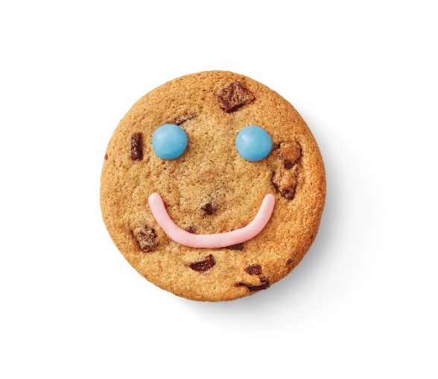

**Pre-Order Form**

**From April 28-May 4,** Tim Hortons Restaurants will be supporting more than 600 local charities, hospitals and community programs across Canada. **Guests who purchase a freshly baked Smile Cookie will be donating to these great causes with 100% of proceeds being donated!** To pre-order Tim Hortons Smile Cookies, complete this form and submit it to the Smythe Street Tim Hortons Restaurant (375 Smythe Street) no less than 48 hours of your specified pick up date & time. Or visit the Tim Hortons app, Uber Eats, Door Dash or Skip the Dishes to see if your Smile Cookies can be delivered.

|  |  |  |
| --- | --- | --- |
| **Number of Cookies:** |  | *12 Cookies per box* |

|  |  |  |
| --- | --- | --- |
| **Your Name:** |  | |
| **Address:** |  | |
|  |  | |
|  | |
| **Telephone:** | ( ) |
| **Email:** |  |

|  |  |  |  |
| --- | --- | --- | --- |
| **Pick Up Date:** |  | **Pick Up Time**: |  |

**Thank you for your support!**

**All proceeds from Smile Cookies sold at the Smythe Street Tim Horton’s location support local kids and youth programs supported through United Way Central NB!   
**