**ABOUT US**

United Way of Central New Brunswick is an organization that works to create long-term, sustainable change that help people to improve their lives and results in stronger, more resilient communities. United Way has traditionally been seen as a fundraiser. However, it is also a convener that brings people together to take action on issues of concern and work towards creating the kind of community that the people of Central New Brunswick want. United Way’s approach includes four key elements:

* **Shared Purpose:** United Way helps the community identify issues that matter most and the actions that will make the most difference. The priorities identified in this strategy take into account the most current local research, and they also link to issues that local people have told us are important.
* **Shared Mobilization of Resources:** United Way does not simply raise funds but seeks to help people to get engaged with their community in meaningful ways, whether that involves donation of time, money, knowledge, or in-kind support.
* **Shared Investment:** United Way invests in meaningful action that makes a difference on the issues that matter to people in their community. This is reflected in its commitment to ongoing evaluation and learning. It is also reflected in United Way’s efforts to collaborate closely with government and with other funders, to raise public awareness, and to advocate for systemic changes.
* **Shared Responsibility:** United Way seeks to build community by bringing people together to develop a sense of shared responsibility for action on priority issues.

**Our investment decisions are made within the framework of the following criteria:**

1. Alignment with United Way focus areas *(see appendix A)*
2. Addresses policy, systems, or institutional change
3. Addresses community need
4. Applies evidence-based effectiveness
5. Addresses underlying causes of social issues
6. Has community support
7. Demonstrates impact
8. Exhibits excellence in performance and leadership
9. Exhibits strong governance

**Eligibility**

* United Way Centraide Central New Brunswick funds charities and other qualified donees. Examples of Qualified Donees include:
  + Registered charities
  + Registered Canadian municipalities
  + Registered municipal or public bodies performing a function of government in Canada

Organizations may seek funds acting alone, or as part of a partnership. Organizations may also seek funds for more than one service. Separate requests should be completed for each service.

* Applications must clearly demonstrate alignment with the United Way Framework and one of the United Way Focus Areas.
* Applications must have identified program, organizational, or community outcomes and identify output measures. *(See appendix B.)*

**Eligible Expenses**

All budget items must be program/initiative-related and incurred by March 31, 2025.

Eligible expenses include wages and benefits, professional fees, travel and accommodations, materials and supplies, printing and communication, equipment rental/lease/maintenance, administration costs, capital costs, and disability support for staff.

**Ineligible Expenses**

The following types of organizations and activities will be deemed ineligible for funding:

* Non-registered charitable institutions unless supported by a qualified organization
* Organizations that are profit orientated
* Activities that are political or religious in nature
* Organizations not operating within the Central NB region
* Individuals
* Annual fund drives
* Deficit financing

**Deadline to apply**

Applications must be submitted no later than **Thursday, November 30 by 11:59 pm AST**. Late applications will not be accepted.

**HOW TO APPLY:**

If you have never applied before, please contact [jennifer@unitedwaycentral.com](mailto:jennifer@unitedwaycentral.com?subject=Community%20Fund%202023) / (506) 459-7773 ext. 206 to get started on our online application platform.

Please complete your application online using **e-CImpact**.

|  |
| --- |
| **For Partner Agencies who have used e-CImpact in the past:**   * Go to the agency login page <https://agency.e-cimpact.com/login.aspx?org=147853>. * **User Name:** Use the same email used in past applications. If you have forgotten or would like to change the email, please contact [jennifer@unitedwaycentral.com](mailto:jennifer@unitedwaycentral.com?subject=Community%20Fund%202023) * **Password:** Use the same password used in previous applications. If you have forgotten your password, there is a “Forgot your password?” function to reset. * The application for the “Community Investments 2024” will appear on the **left hand side under the “Apply/Report” menu.** * **Note for returning agencies:** As advised on Oct 25, 2023, our application process has changed. Details are at the bottom of this page. |
|  |

|  |
| --- |
| **Registering a New Agency**   * Go to <https://agency.e-cimpact.com/login.aspx?org=147853>. * **Step 1:** From the agency login page select ‘Click here to create new e-CImpact Account’ * **Step 2:** Please read all directions carefully, and then click ‘Next’ to continue with your registration process. * **Step 3:** Please enter all required information regarding your agency. Then proceed to the next page. * **Step 4:** Select a grant application you would like to apply for, and then continue to the next page. * **Step 5:** Review all agency information entered, and then click ‘Complete Registration’. * **Step 6:** You will be able to access the agency site once approval is granted by admin. Please allow 1 business day for approval to be granted. Admin will reach out if approval will not be granted. Once approved, the application for the “Community Investments 2024” will appear on the **left hand side under the “Apply/Report” menu.** |

**Process Change for 2024-25 Funding Cycle:**

In prior years, applicants would submit an application in November/December, then would have to wait until March/April of the following year to hear if their application was successful and the amount they’ll receive. In an effort to minimize this delay, we are implementing a two-phase approach similar to some other United Ways.

**Phase 1: Letter of intent**. This will open November 1 (in e-CImpact).This set of questions asks about the mission of your organization, the intent of the program, the funding amount being requested, and governance and financial accountability.

**Phase 2: Full application**. Successful letter-of-intent applicants will be asked to complete the full application (available in January). Unsuccessful applicants will be informed within December that their application will not be considered for funding. This will allow those organizations time to secure alternative funding or adapt their programming as needed.

Being invited to complete the full application after a successful letter of intent does not *guarantee* funding. However, it indicates United Way is greatly interested in the organization and its program and will seek to provide a financial investment.

If you have any questions or need further information, contact Jennifer McEathron at [jennifer@unitedwaycentral.com](mailto:jennifer@unitedwaycentral.com?subject=Community%20Fund%202023) or 506-459-7773 ext. 206.

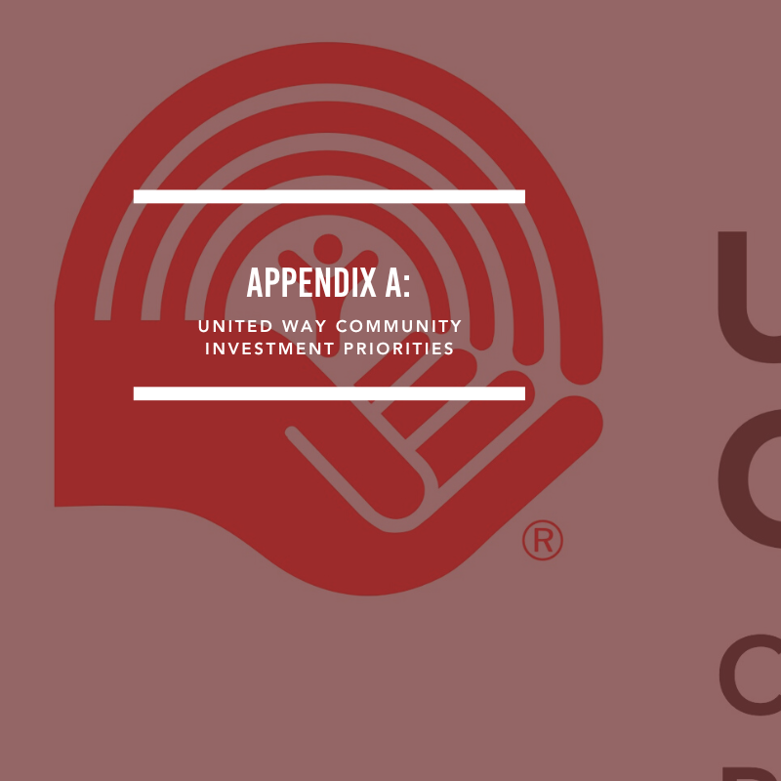

* Housing
* Food Security
* Youth
* Disabilities
* Mental Health
* Personal Safety
* Education and Employment

NOTE: Appendix B & C are not relevant to the Letter of Intent phase. They are intended for the full-application phase.

Agencies are required to track a minimum of 3 outputs. An “Other” option is available if none of the types accurately describes your program/initiative. United Way may work with you to set additional or different outputs after reviewing the application.

**Top of Form**

**Food Security**

* # of meals provided
* # of individuals connected to food support programs
* # of food related information or skill building sessions provided
* # of food baskets/hampers provided
* # of essential items provided (reporting will require the description of the essential items)
* # of deliveries made

**Financial Wellness & Employment**

* # of individuals connected to income support programs
* # of financial counselling sessions provided
* # individuals supported to maintain employment
* # individuals matched to available employment opportunities
* # employment training sessions offered
* # assessments made with individuals to determine employment options

**Home Care or Personal Support**

* # of unique individuals receiving home visits
* # of individuals provided with hospice care
* # of homecare visits provided/enabled
* # of essential items provided

**Health & Hygiene**

* # programs provided to improve quality of life while in care
* # of medical item deliveries made
* # of individuals receiving financial assistance for medical equipment or services
* # of hygiene item deliveries made
* # of health information sessions provided
* # individuals attending support groups

**Information & Navigation**

* # unique individuals supported
* # text/chat assists
* # resources distributed (print copies)
* # resources developed
* # participants attending information sessions/workshops
* # of contact sessions
* # group information sessions/workshops provided

**Advocacy or Legal Support**

* # unique individuals supported with legal or advocacy issues
* # policies influenced or developed
* # participants attending information sessions/workshops
* # of contact sessions to discuss legal or advocacy needs
* # group information sessions/workshops provided

**Mental Health & Wellness**

* # unique individuals counselled
* # support-group sessions provided
* # participants attending information sessions/workshops
* # of one-on-one counseling sessions
* # individuals matched with a mentor (specific to buddy or mentor programs)
* # of support group sessions provided
* # of individuals attending support groups
* # of information sessions/workshops provided
* # of participants attending information sessions/workshops

**Shelter, Refuge, Housing, and Outreach**

* # of individuals sheltered
* # of bed-nights of shelter provided
* # individuals transitioned to available housing
* # assessments made with individuals to determine service needs and/or acuity level
* Average # of monthly interactions with individuals in program
* # of unique individuals supported through service
* # of people who exited caseload since beginning of contract year
* # of people re-housed out of shelters
* # of people re-housed from rough sleeping
* # of people re-housed from other circumstance (institution, hospital, corrections)
* # of new clients since beginning of contract year
* # of existing clients (at beginning of contract year)
* % of individuals identified as high acuity
* % of individuals identified as moderate acuity
* % of individuals identified as low acuity
* % identified as chronically homeless
* % identified as transitionally homeless
* % identified as episodically homeless

**Personal Safety (*specific to domestic and gender-based violence**)

* # of training sessions provided to emergency responders or essential service providers
* # of personal safety mentors matched
* # of personal safety assessments made
* # safety plans developed

**Learning & Social Inclusion**

* # of social activities offered
* # of learning aids provided (i.e. laptops)
* # of learners engaged
* # of individuals connected with a peer mentor
* # of adapted equipment and technical aids provided (e.g., wheelchairs, walkers, commodes, prosthetics, white canes, hearing aids, reachers, adapted cooking devices)
* # individuals supported to commence/continue post-secondary education
* # assistive technology & software provided (e.g., audio recorders, pen grips, iPads, computers, voice recognition, word prediction)
* # assessments with individuals to determine needs and goals
* # of learning sessions offered

**Transportation / Transport**

* # of persons transported
* # bus tickets provided
* # bus passes provided

Bottom of Form

This appendix contains a template for recording budget information for your program, strategy, or service.

* Please ensure that your budget accounts for the full income and expenses of your service, including grants you have requested. All budget items must be service related and must be incurred during the grant period.
* Eligible expenditures include: wages and benefits, professional fees, travel and accommodations, materials and supplies, printing and communication, equipment rental/lease/maintenance, administration costs, capital costs, and disability support for staff. Ineligible expenditures include purchase of real property.
* Please note, other sources of revenue cannot be used for the same activity costs described in this application, without a commensurate increase in services.
* Where there are multiple sources of income from the Federal Government, Provincial / Territorial Governments or Municipal Governments, please add lines to the table to detail each.

|  | **Proposed** | **Confirmed** | **Amount** |
| --- | --- | --- | --- |
| **Income:** |  |  |  |
| Federal Government Sources (specify): |  |  |  |
| 1. |  |  | $ |
| Provincial / Territorial Government Sources (specify): |  |  |  |
| 1. |  |  | $ |
| Municipal Government Sources (specify): |  |  |  |
| 1. |  |  | $ |
| orporate / Donor Support: |  |  | $ |
| Other (list top 3 sources): |  |  |  |
| 1. |  |  | $ |
| 2. |  |  | $ |
| 3.d |  |  |  |
| All other combined |  |  | $ |
|  |  | ***Total Income:*** | $ |
| **Proposed Expense:** |  |  |  |
| Wages and Benefits: |  |  | $ |
| Disability Supports for Staff: |  |  | $ |
| Professional Fees: |  |  | $ |
| Travel and Accommodations: |  |  | $ |
| Materials and Supplies: |  |  | $ |
| Printing and Communication: |  |  | $ |
| Equipment Rental/Lease/Maintenance: |  |  | $ |
| Administration Costs: |  |  | $ |
| Capital Costs: |  |  | $ |
|  |  | ***Total Expense:*** | $ |
|  |  |  |  |
|  |  | **Balance:** |  |