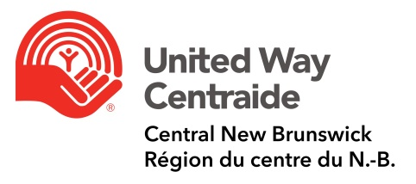

Reporting instructions for GNB Team Captains

Every Friday the team captains report is completed, signed and emailed to Pam pam@unitedwaycentral.com

Balancing the captains report (pledge forms, money collected) should always be done in pairs. If another person from your workplace is not available, please ask Pam or Anne at United Way to balance the report with you.

The captain’s report must balance with each of the deposits. All cash and cheques collected are deposited at Scotiabank located in Kings Place Mall. This is done on a weekly or bi-weekly basis and at a time convenient to you. Deposit books are provided by United Way.

Credit card and debit donations are now done online at www.unitedwaycentral.com Tax receipt are emailed directly to the donor when the donation process is completed.

Keep all completed pledge forms and money in a secure place until the forms are submitted to United Way and money is deposited.

Submit pledge forms on a regular basis. Please DO NOT wait until the end of your campaign to submit. Pledge forms can be delivered to the United Way office (1-385 Wilsey Road) or brought forth during the monthly team captains’ meeting.

**Deadline for payroll December 1, 2021

For payroll deduction pledges - SNB processes all GNB department payrolls using the HRIS payroll system the exceptions are Crown Corporations, Service NB-HQ and SNB-Health (Meditech) who have their own payroll departments and payroll systems. The pledge forms that have payroll deduction should be submitted to the Departments H/R representative, as the HRIS payroll system requires a guarantor to authorize changes to an employee's payroll file. Most H/R employees are guarantors and can generate the form. The guarantor will complete the change form and send it to the payroll representative along with the United Way pledge form. The bottom portion is all that is required, but the entire form can be sent PROVIDED United Way has been given a copy of the form. United Way requires the forms to carry out the donor’s wishes.
It is the team captain’s responsibility to collect all the pledge forms from the canvassers and either take them to the H/R representative or payroll as it is possible that employees can be on either payroll system.

All pledge forms with cash/cheque donations are also sent to the United Way office. The bottom portion can be signed by the team captain and given to the donor as a temporary receipt.

**NOTE: Any payroll deduction pledges received from SNB employees located in your department are NOT included in your report, do not count toward your goal and must be given to the SNB team captain, Deanna Young, Deanna.Young@snb.ca

**NOTE: All cash/cheque donations and special event money received from SNB employees located in your department are deposited by you, included on your captain’s report and count toward your goal.

**NOTE: Any payroll deduction forms received from employees in Moncton and Saint are included on your captain’s report, and they count toward your goal. Send to Pam and she will forward to the respective United Way. Team captains must send the bottom portion to HR/Payroll.

**NOTE: Any cash/cheque donations received from employees in Moncton and Saint John are included on your captain’s report, deposited by you, and count toward your goal. At the end of the campaign Pam will forward all money collected to the respective United Way.

Tax Receipts: Payroll deduction donation receipts will appear on the 2022 T4. Pam will process charitable receipts for all cash/cheque donations and send directly to donor.

If you have any questions, please contact Pam Brown at United Way.
Email: pam@unitedwaycentral.com Telephone: 459-7773 x 203

