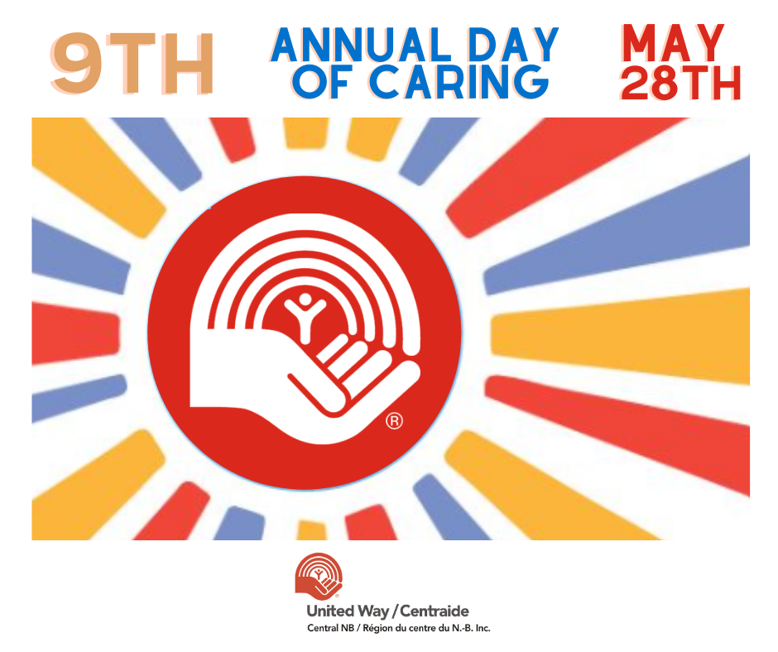

2021 United Way- Day of Caring Project Proposal
*TEST Agency* - Basic Agency Information
Welcome to United Way of Central New Brunswick’s Day of Caring Project Proposal form!

Day of Caring is a special program coordinated in your community by United Way Central NB. Our goal is to mobilize teams of corporate employees as volunteers and to complete meaningful, hands-on projects that will greatly assist local non-profit agencies in Fredericton, Oromocto and surrounding areas. This is a great chance for your agency to elevate its profile with caring volunteers and donors, and to get a much-needed project off your to-do list.

This year’s Day of Caring will take place on Friday May 28th, 2021.

To help adjust to Covid-19 regulations, we have expanded this year’s Day of Caring to include two new types of projects in addition to on-site projects: 1. Virtual projects will allow volunteers to share their skills from the safety of their office or homes, and 2. The collection of care packages will encourage corporate teams to collect donations leading up to our Day of Caring to meet specific needs identified by our not-for-profit community.

We encourage agencies to explore the various types of possible projects from the list below and to submit applications by Wednesday April 7th, 2021. Our United Way team will then do its best to find a match for your proposed project.

Timeline:
- April 7th: Deadline to submit Day of Caring applications
- April 9th: Projects will be reviewed for approval. Agencies will be notified.
- April 12 – May 7: UW will recruit and match corporate volunteer teams to projects.
- May 8- May 28: Virtual Projects and Care Package Projects may commence.
- May 28: United Way Day of Caring! On-site projects happen on this day. Virtual projects can be completed by or on this day. Care packages are delivered to agencies on this day.
** Please email completed applications to roxana@unitedwaycentral.com **

ON-SITE PROJECTS | VIRTUAL PROJECTS | CARE PACKAGES
Cleaning, Painting, Construction, Administrative/Office Tasks. Landscaping, etc.. | Website support, data entry, newsletters, graphic design, impact story write ups, survey development, virtual English language support, online tutoring, friendly calls/conversations, agency consultations with content experts, etc. (see full descriptions below) | A variety of care package are prepared and dropped off by volunteers. Contents of these packages are purchased/ donated by the volunteers (see full descriptions below)

COVID-19 SAFETY
Click here for up-to-date COVID-19 Public Health Alert Levels and Public Health measures and guidelines

Click here for Public Health Measures for businesses, educational institutions, organizations and service providers

✓ COVID-19 Operational Plan
✓ Active or passive screening of employers and patrons
✓ Physical distancing
✓ Masks
✓ Frequent hand washing and surface cleaning

YOUR ORGANIZATION

- Organization Name: Click or tap here to enter text.
- Key Contact(s):
Name: Click or tap here to enter text.
Phone (day of project): Click or tap here to enter text.
Email: Click or tap here to enter text.
- Back-up Contact:
Name: Click or tap here to enter text.
Phone (day of project): Click or tap here to enter text.
Email: Click or tap here to enter text.
- Social Media Tags (for promotion): Click or tap here to enter text.
- I am submitting the following Day of Caring Project Proposal(s):
Feel free to submit more than one.
☐ On-site project (Complete pages 3-4)
☐ Virtual project (Complete page 5)
☐ Care Packages (Complete pages 6-7)
ON-SITE PROJECTS

- Project Name: Click or tap here to enter text.
- Project Type(s):
☐ Cleaning  ☐ Painting  ☐ Construction | ☐ Administrative/Office tasks  ☐ Landscaping  ☐ Other: Click or tap here to enter text.
- Description of project:
Click or tap here to enter text.

- Minimum # Volunteers Needed: Maximum # Volunteers Needed:
- Location of project (full address, specific direction if needed, and meeting point):
Click or tap here to enter text.
- ☐ Indoor ☐Outdoor
- Date of Project (UW Day of Caring is Friday May 28, 2021): Click or tap here to enter text.
☐ Click here if the date is flexible
- Time of Project:
☐ Full Day Project (9AM-4PM) ☐ Morning Project (9AM-12PM) ☐ Afternoon Project (1PM-4PM) | Or, specify time:  Start Time:  End Time:

- Will this project continue in the rain?
☐ Yes ☐ No
- Will snacks and/or lunch be provided?
☐ AM Snack ☐ Lunch ☐ PM Snack
- Do volunteers need to bring any equipment (i.e., tools) or wear specific apparel (i.e. safety goggles, gardening gloves, etc.)?
☐ Yes. Please specify: Click or tap here to enter text.
☐ No, everything will be available on-site.
- Do volunteers need to have any specific skills?
Click or tap here to enter text.
- Are there any safety concerns for the volunteers?
☐ Yes ☐ No
If yes, please describe the concern and if it can be alleviated easily.
Click or tap here to enter text.

- COVID-19 Precautions: My project WILL continue in these COVID-19 Public Health Alert Levels (select all that apply):
☐ Yellow Level
☐ Orange Level
☐ Red Level

Volunteers will be advised to follow Public Health’s guidelines when they volunteer. If you have additional instructions or requirements, please include them here:
Click or tap here to enter text.

** Please email completed applications to roxana@unitedwaycentral.com **

VIRTUAL PROJECTS

- Project Name: Click or tap here to enter text.
- Description of virtual project:
Click or tap here to enter text.
- Minimum # Volunteers Needed: Maximum # Volunteers Needed:
- Date of Project (UW Day of Caring is Friday May 28, 2021): Click or tap here to enter text.
☐ Click here if the date is flexible

- How many hours will this virtual project take (in total)?

- Are you looking for volunteers with any specific skills?
Click or tap here to enter text.

** Please email completed applications to roxana@unitedwaycentral.com **

CARE PACKAGES

Where can the Care Packages be dropped off? Click or tap here to enter text.

Type(s) of Care Package Needed: (please select) | Items included | Quantity of Kits Needed:
☐ Baby Essential Kits | ✓Diapers  ✓Formula  ✓Baby wipes  ✓Baby blanket  ✓Baby bath wash  ✓Baby shampoo  ✓Baby Book or Toy  ✓Baby Bag or Tote Bag
☐ COVID-19 Protection Kits | ✓Face Masks  ✓Gloves  ✓Disinfectant cloths  ✓Bar of soap  ✓Hand Sanitizer  ✓Laundry Detergent
☐ Family Meal Kits | Option A:  ✓Jar of Pasta Sauce  ✓Spaghetti Noodles  ✓Dry Parmesan Cheese  ✓Salad Dressing  ✓Basket/Bowl (to hold ingredients)  Option B:  ✓2 Cans of Chickpeas  ✓Packet of Basmati or Long Grain Rice  ✓Can of Tomato Paste  ✓Small Packets of Spices – turmeric, chilli, coriander, cumin  ✓Basket / Bowl (to hold ingredients)  Option C:  ✓One Pack of Shelf-Stable Tofu  ✓Packet of Long Grain Rice  ✓Packet of Asian Noodles  ✓Soy Sauce  ✓Basket / Bowl (to hold ingredients)  Option D:  Click or tap here to enter text. | Option A:  Option B:  Option C:  Option D:
☐ Welcome Home Kits | ✓Dish soap  ✓Dish brush/sponge  ✓All purpose cleaner  ✓Cleaning sponges  ✓Toilet brush  ✓Carrying tote
☐ Snack Pack Kits | ✓6-7 nutritious snack items (nut-free& shelf stable)  ✓ziplock bag
☐ Feminine Hygiene Kits | ✓Feminine pads  ✓Feminine protection tampons  ✓Deodorant  ✓Body wash
☐ Hygiene Kits | ✓Toothbrush  ✓Toothpaste  ✓Deodorant  ✓Shampoo & Conditioner or Shampoo 2-in-1  ✓Body wash  ✓Hand wipes or sanitizer  ✓Band-aids  ✓Comb or brush  ✓Soap  ✓Socks
☐ Cozy Kits | ✓Box of hot cocoa packets  ✓Puzzle book or Puzzle  ✓Box of mini candy or cookies  ✓Mug or basket
☐ Literacy Kits for Kids | ✓1-2 children’s books  ✓Related activities such as puzzles, coloring books  ✓Crayons or pencil colors  ✓Small bag
☐ Activity Kits for Kids | ✓Tote Bag  ✓Coloring Book  ✓Crayons  ✓Stuffed Animal or Toy  ✓Stationery – Pens, pencils, erasers, notepads, sharpeners  ✓Stickers  ✓Craft Supplies (Ex: Pom Poms, Pipe Cleanings Googly Eyes, etc.)
☐ DIY Gardening Kits | ✓Containers such as egg cartons, Dixie cups, plastic food containers or water bottles to startseeds  ✓Seeds such as lettuce, basil, peppers, mushrooms, any other herbs or vegetable seeds  ✓Potting soil, topsoil or any dirt will work for starting seeds  ✓Plant pots (optional)
☐ Kits for Seniors | ✓Crossword Book  ✓Post Cards  ✓Coloring Sheets  ✓Puzzles  ✓Pens  ✓Candy  ✓Letter pad  ✓Tote bag
☐ Notes for Community Frontline Worker | Tell us who the frontline workers are: Click or tap here to enter text.
☐ Other- Build your own | Tell us what you need (be specific): Click or tap here to enter text.

** Please email completed applications to roxana@unitedwaycentral.com **

