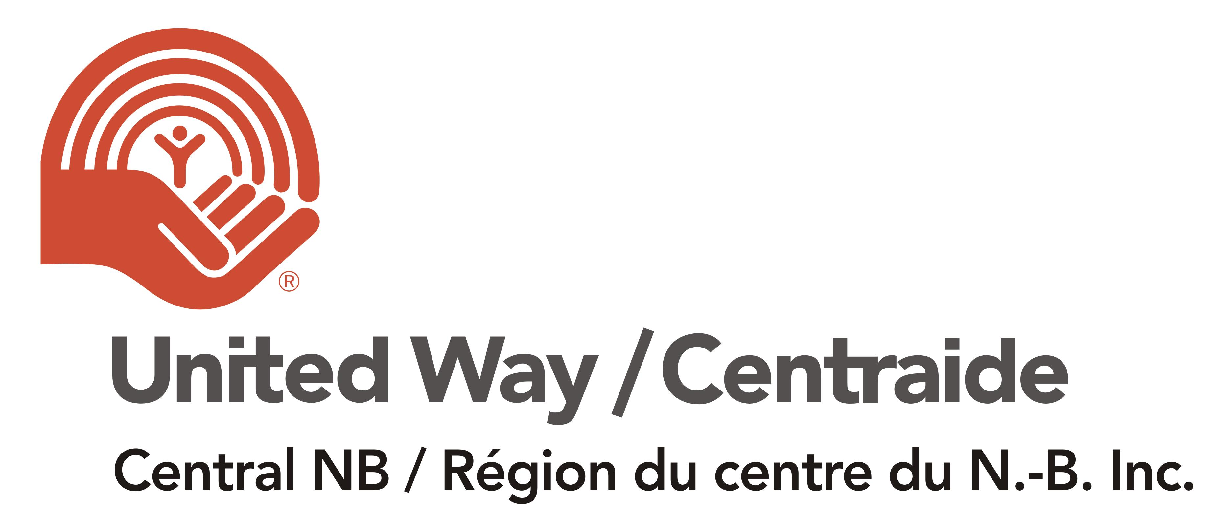
VIRTUAL FUNRAISING EVENTS – BRIGHT IDEAS
Ideas for online and virtual campaign fundraisers and special events to make your campaign great!!
Physical Activities:
- Virtual Workout Fundraiser: Host a virtual workout for your colleagues either teaching it yourself or suggesting everyone pulls up the same video on YouTube ex. everyone does a "Yoga with Kayla" video while logged into zoom. Then donate the $5 you would have spent on a drop-in class.

- A physical challenge: For every $10 raised, they commit to climbing flights of stairs, doing a number of push-ups, planks, or some other physical feat.

Food and Nutrition Activities:
- Virtual Cooking Lessons Fundraiser: Have local chef perform cooking lessons and teach a few dishes. People can pay to register to the event and/or have raffles through the event.
- Digital Cookbook: Folks could each contribute a favourite family recipe and then staff could pay $5 to have access to the full digital cookbook.

- Food packages fundraiser: Where you partner with a local business. For example, the package is worth and sold at $50 and 10% ($5) or other percentage. For example: A meat box from a local butcher shop, a vegetable box from a local market.

Entertainment, Art, and Culture Ideas:
- Movie Watch party: Host and invite your friends to watch the latest shows or a movie, everyone donates what they would have spent going to the theatre and you all enjoy chatting about your favourite scenes, favourite character, what snack pairs best with the episode etc.
- No-Binge Netflix Challenge: Select a new Netflix series to watch together, but you can only watch 1 day/week. Yep, we are going old school! Send out a weekly challenge/poll on what people think will happen in the next episode. Give a donation to participate in series challenge and bragging rights to weekly poll winners.
- Local Music Night Fundraiser: Ask a local musician to do an online performance with ‘’Tip Jar’’ for donations.
- A Read-a-thon or Book-a-thon: where the participant asks their friends and family to support them by the book or by the minute.
- Paint Night Online (Pay what you can): Virtual paint night with everyone following the same instruction video on YouTube or someone volunteers to play host.
- Online Gaming Tournament Fundraiser: An all-day or evening game challenge for charity, collect pledges, and play a video game or board game for “X” hours straight.

Fun and Funny ideas
- Office Talent Show: Think your co-workers are a super talented bunch just waiting for their moment to shine? Host a virtual talent show and ask them to record and upload a 2-3 minute video of themselves showcasing their talent (think singing, playing an instrument, doing a magic trick, or juggling fruit!). Encourage people to vote for their favourite act by donating, where every donation is a vote towards selecting a winner. The act with the highest dollar amount raised wins! To raise even more money, consider asking for a registration fee from all the contestants, or asking executive leadership to sponsor a contestant, and have it count towards their total money raised.
- Isolation Beard/Hair fundraiser – Grow hair or beard challenge, fee to get in the challenge ($10 example) and a cost if you shave/cut before the end ($100).
- Haircut Fundraiser: Try a home haircut and donate what you would have spent going to the barber or salon. Even better have your colleagues join you virtually and laugh together as you shave your heads or try a new style.
- A “Dare” Fundraiser: For every specific amount raised, someone commits to doing something that friend dares them to do. (Get management involved to motivate staff)
- A new kind of Casual/Jeans Day: Instead of jeans day you could donate to wear your pajamas while you work from home or host a fancy virtual staff meeting where everyone dresses in their fanciest clothes, it could even be a jersey day and everyone wears a jersey for the sport they’re missing the most. Perhaps have “theme” meetings where everyone dresses up to that theme. (Think ‘80s with big hair and bright clothes!)
- Virtual scavenger hunt: With either things from around the house or that you would find on a walk around the block. Your entry fee is a donation and perhaps there is a prize for whoever submits photo evidence of having located all the objects first.
- Trivia Night: Host a virtual trivia night, pick a theme, set the time, and have everyone join you via Zoom/Microsoft teams etc. for some fun.
- Jeopardy Game: Host and play a jeopardy style game using JeopardyLabs - https://jeopardylabs.com they have tons of great templates already built.

Other Ideas:
- Online Auction - Individual or Collective: Since people are buying a product you can e-transfer and this does not require a lottery license. Besides offering a variety of unique and useful items, remember to also include services (when the situation permits) and virtual experiences. Encourage donations of popular items (gift cards, gift baskets, etc.), as well as unique and rare ones (sports memorabilia, autographed items, virtual coffee with a prominent person within your organization, etc.) People are more likely to support and bid if it is for a good cause, so variety is key. One great resource is https://www.32auctions.com/
- A Zoom Bingo: Where you have either cash prize or donated prizes and entry fees.
- A Home Party Type Fundraiser: Where you receive a % of the orders. Find your local representative and connect with them to organize an event. Some popular home party opportunities are Tupperware, Scentsy, Epicure, Tiber River, etc.
- Coupon Book & Peeler / Gift Card Basket fundraisers: Support and partner with local restaurant for gift card and sell tickets (winner can use to order food by delivery) or selling peelers cards of values or coupon books usually you would receive a % of the amount sold.
- Donate your commute/coffee/parking/daycare, etc.: Where a lot of people are working from home, not commuting, paying for parking, and perhaps no daycare costs; they can consider donating that amount.
- 50/50 and Raffles - Due to GNB lottery license regulations on raffles (including 50/50), all tickets must be physical tickets and the draw must done manually (you cannot use an online raffle platform or a random winner picker site). You can live stream the draw if you wish but it is not necessary. If employees are working from home, lottery license regulations allow for e-transfer for payment of “lottery” tickets, with the following rules:
- Funds must be sent to one email address that belongs to the organization and the funds must be deposited into a bank account also in the organization’s name (cannot be a personal bank account for auditing purposes). Also, you must ensure that the ticket purchaser is a resident of New Brunswick.
If you don’t already have a bank account in place for your organization’s special event/employee funds, many banks offer low-fee options for such accounts. I would encourage you to reach out to your local bank today to find out more info and set up an account.

