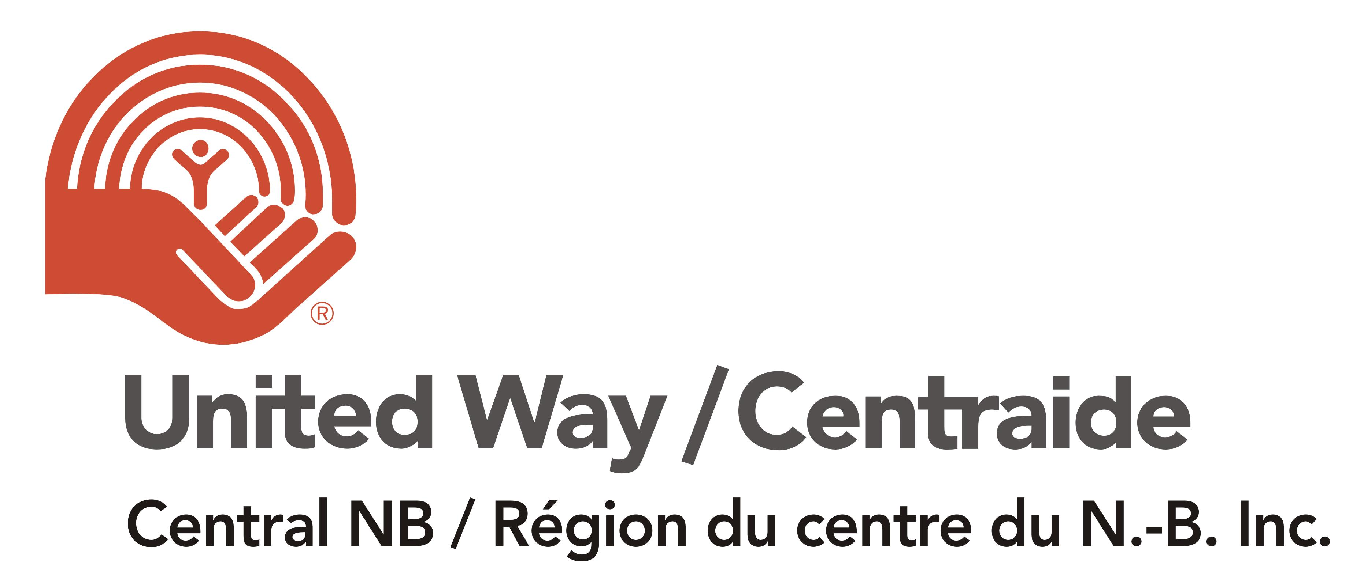
Cash Transactions Protocol In a Covid-19 Scenario

Cash Handling Protocols | United Way of Central NB COVID-19 Cash Transactions Guidelines
Purpose of the Protocol | This protocol provides a recommended preventive measures for campaign chairs and employees during a Pandemic scenario of COVID-19.
Who does this protocol apply to | This protocol applies to all Government of Employes handling cash as part of United Way activities which require cash collection. The Campaign Chairs should take responsibility for implementing these procedures.
Disclaimer | This protocol was prepared by United Way of Central NB (UWCNB) based on the recommendations of the World Health Organization (" WHO "), external consultants and the experience of the organization itself. UWCNB is not responsible for the result of the implementation of the protocol and in no way guarantees the effectiveness of this material to prevent or reduce CORONAVIRUS (COVID-19) infections among its employees. Authorization to use this material is exclusively and limited to consultation. No person or entity will be able to use this material, in whole or in part, for publicity, advertising and/or promotion in any material or media, for any company, products or services.
I. Preventive Measures for Cash Transactions
1 | Cash exchanges should be discouraged wherever possible and contactless payment options should be encouraged (i.e. debit or credit cards, wire transfers, etc.). 1.1 If NO option other than using cash, consider that all cash handling policies will remain in place during COVID-19.
1.2 | Where credit cards or debit cards are used, payment receiving devices, and cards should be sanitized with disinfectant wipes after each use. a. Never spray disinfectant directly into the terminal or its components. b. Never reuse wipes/paper towels. Dispose of it after every use.
2 | All personnel should always wear COVID-PPE (i.e. gloves and mask)
2.1 | Maintain a minimum of 2 meters (6 feet) separation between people or a barrier should be set up whenever people-to-people proximity is unavoidable. This can be used by putting a table between you and the collection area or a jar or collection bin which can be monitored safely from a distance.
3 | Any personnel that uses cash will always require using gloves and wash or sanitize hands every time cash is handle (even with gloves). The counter must be disinfected frequently.
4 | A thorough cleaning scheme must be in place for areas where people-to-people interactions take place to ensure these areas are free from potential COVID-19.
4.1 | Increase the cleaning and disinfecting activities frequency for all the areas where people have direct and constant contact (i.e. Chairs, desks, doors, etc.)
Cash Transactions Protocol in a Covid-19 scenario
I. Preventive Measures for Cash Transactions
4.2 | Increase the cleaning and disinfecting activities frequency for all the equipment used by people such as monitors, keyboards, mouse, etc.
4.3 | Cash and coin can also be left in a secure location for 2 days to increase safety when handling cash. Gloves and a mask should still be worn when handling cash at any stage.

